Digital Image Analysis Tutorial 4
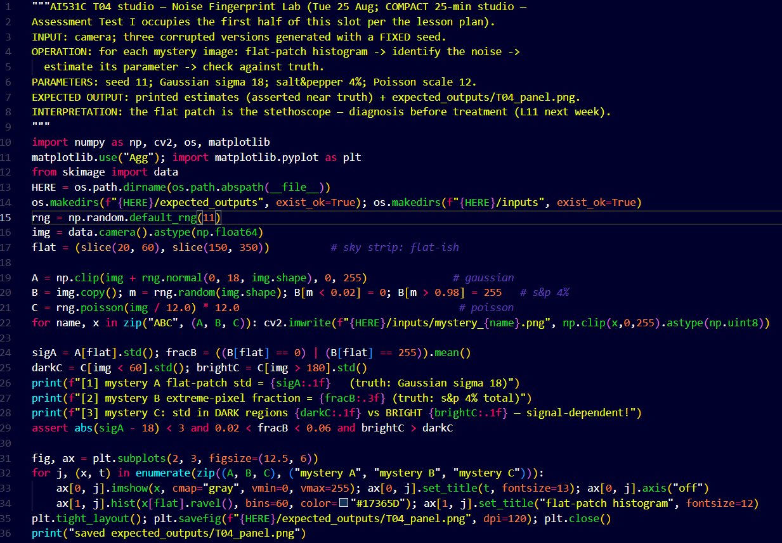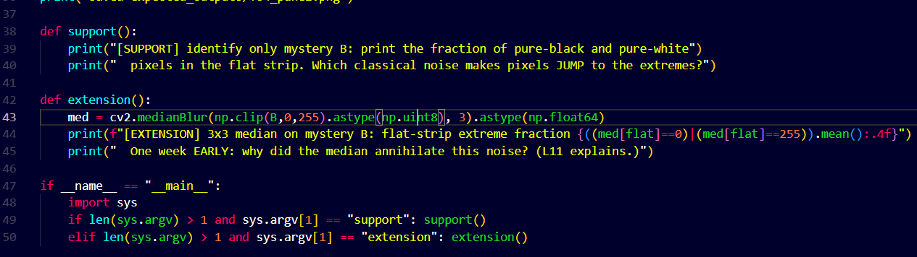

Output Images:
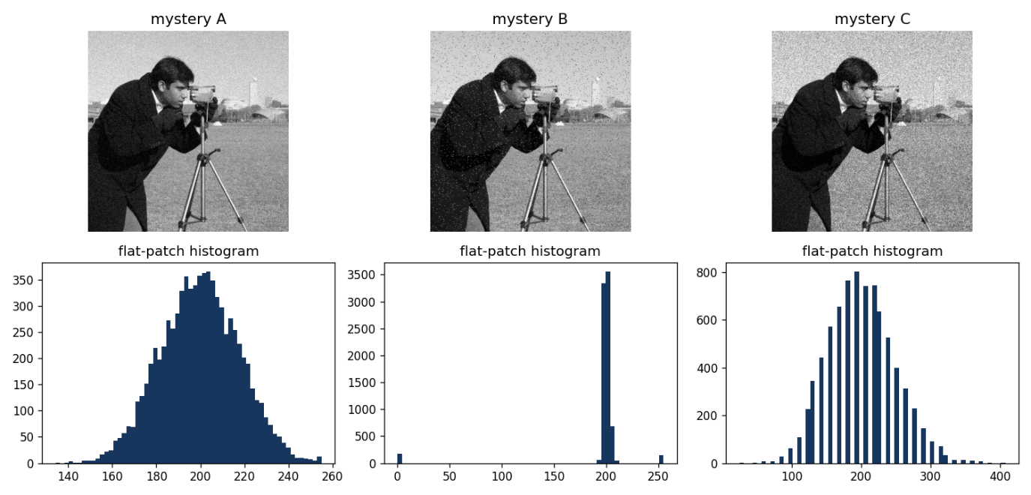

Image A
Image A represents the Gaussian Noise
Image B
Image B represents the Salt and Pepper Noise

